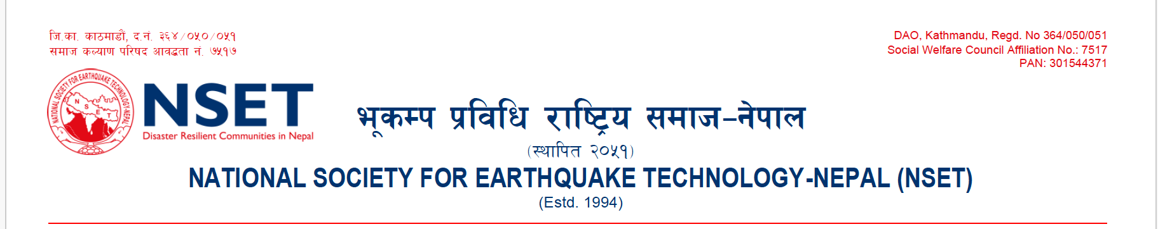

Application Form for Volunteer at NSET

Thank you for your interest to Volunteering at National Society for Earthquake Technology-Nepal (NSET). This application form will help us identify the team and jobs that are best suited to your experience and learning objectives. Please fill up this application form and submit to volunteer@nset.org.np .

______________________________________________________________________________________________

First Name Middle Last Name

Home Address: _________________________________________________________________________________

Home Phone: ___________________________ Personal Contact Number :_______________________________

Personal Email:________________________________________

Current Involvement at: ___________________________________________________________________________

Position: ____________________________________________ Period of Current Position____________________

Address: _________________________________________________________________________________

Phone: _______________________________ Email: _________________________________________

Mobile Phone (Optional):

VOLUNTEER INTEREST

Volunteer Request for:

Time and Duration:

Outline what you expect to learn or achieve from this Volunteering?

Why are you interested in Volunteering at NSET? __________________________________

Are you Volunteering at NSET as per Memorandum of Understanding (MOU) with your organization? □ Yes □ No

Are you Volunteering at NSET with your direct approach? □ Yes □ No

If yes, how did you know about NSET? ______________________________________________________________

Are you a student? □ Full Time □ Part Time □ No

If student, what program are you in? ____________________________________________________________

Will your Volunteering hours count towards university class credit? □ Yes □ No

If so, what is the name of the course or faculty advisor: __________________________________________________

Please specify the College/University degrees obtained/expected __________________________________________

What is the source of support to you for Volunteering at NSET?

– Self support - Institutional support - Scholarship Other (specify)_________________

VOLUNTEER/INTERNSHIP EXPERIENCE

List previous experiences (paid or educational) that would be helpful in working with people.

Activity Organization Date(s)

__________________________ ___________________________________ _____________________________

__________________________ ___________________________________ _____________________________

PUBLICATIONS (if any):

_________________________________________________

_________________________________________________

ELIGIBILITIES

Academic Qualifications:
Trainings/ Skills:
Language Proficiency:
Professional Experiences:

List any additional skills, hobbies or interests you have that might be helpful in your work:

______________________________________________________________________________________________

AVAILABILITY

Approximately how much time do you feel you could do Volunteering (per week/month)? _______________________
How many months would you like to do Volunteering at NSET? ___________________________________________
What is your preferred work schedule?

(Check all applicable)  ___ Daytime  ___ Evenings  ___ Weekdays  ___ Weekly  ___ Monthly | Mon Tue Wed Thu Fri  Preferred Schedule (if known):  _____Time Commitment Undecided

OTHER RELEVANT INFORMATION:
Have you ever been arrested or summoned into Court as a defendant in a criminal proceeding, or convicted, fined or imprisoned for the violation of any law? □ Yes □ No
If yes, please give full details in a separate paper.

REFERENCES

Personal or professional references (Please list two persons excluding your relatives, who are familiar with your character and qualifications)
Referee 1 | Referee 2
Name:  Address:  Organization / Institution:  Contact Number:  Email Address: | Name:  Address:  Organization / Institution:  Contact Number:  Email Address:

EMERGENCY CONTACT INFORMATION
Individual to be notified in case of emergency:
 | Primary Contact | Secondary Contact
Name
Relationship
Address
Contacts
Email

THE ABOVE INFORMATION IS ACCURATE AND CORRECT TO THE BEST OF MY KNOWLEDGE.

SIGNATURE _____________________________________________________ DATE ________________________

[Your signature indicates your approval for us to check your references. The organization is not obligated to provide a placement, nor are you obligated to accept the position offered. Opportunities for volunteers and interns are provided without any regard to religion, race, national origin, age or sex. NSET is not responsible for obtaining internship visa for the international applicant.]

Thank you for your interest to work with NSET and contribute for making disaster resilient communities!

Volunteering for the period of 3 months and above

